Town of Colton
Greenhouse Gas Inventory for Government Operations
2019 Summary Report

Credits and Acknowledgements
This report was prepared by Darren Richards, DPW Superintendent, with the help of the Adirondack North Country Association (ANCA).

Background
The Town of Colton recognizes that greenhouse gas (GHG) emissions from human activity are causing climate change, the consequences of which pose substantial risks to the future health and well-being of our community. To demonstrate its commitment to addressing the growing threat of climate change, in 2023 the Town of Colton became a registered Climate Smart Community by formally adopting the New York State Climate Smart Communities (CSC) pledge.
The CSC program, administered by the New York State Department of Environmental Conservation (DEC), is a certification program that provides a robust framework to guide the actions local governments can take to reduce GHG emissions and adapt to the effects of climate change. The first step in this process is to perform a GHG Inventory for all buildings, vehicles and operations controlled by the local government. Using data from 2019, this GHG inventory provides a baseline for which the Town can set emissions and operation costs reduction goals, determine ways in which those goals can be reached, and track progress.
This GHG Inventory for Government Operations Report summarizes the GHG emissions from the Town of Colton’s consumption of energy and materials within town-owned buildings, the Water Treatment Plant, vehicle fleet, outdoor lighting, and other facilities. This data was generated from electric, propane, fuel oil, and kerosene bills for all Town owned buildings and operations, as well as fuel records for the Town’s vehicle fleet. The GHG emissions for all local government operations are measured in metric tons of CO2 equivalents (CO2e) and were calculated using emissions factors by the US Energy Information Administration (EIA), US Environmental Protection Agency (EPA) and the Climate Action Associates (CAA), LLC’s GHG Inventory Tool.

key findings
In 2019, GHG emissions from Town of Colton’s government operations totaled 368.92 MTCO2e. Figure 1 shows the emissions for government operations broken down by sector. The vehicle fleet account for the largest percentage of GHG emissions at 58%. The second largest contributor are the administration facilities (buildings) at 34%. Street lights, water delivery, water treatment, and solid waste processing account for the rest of emissions.

The Inventory Results section of this report provides a detailed profile of emissions sources within the Town of Colton. This data will also provide a baseline from which the Town will be able to compare future performance and demonstrate progress in reducing emissions.

Figure 1: Town of Colton GHG Emissions by Sector for 2019 Pie Chart

Data gathering and methodology
The first step toward achieving tangible greenhouse gas emission reductions requires identifying baseline emissions levels and sources and activities generating emissions in the community. The Town of Colton is focusing first on government operations emissions to lead by example and will inventory community-wide emissions in a future report.
The CSC Task Force appointed DPW Superintendent, Darren Richards, to lead the GHG Inventory data collection effort, with the help of the Adirondack North Country Association (ANCA). The GHG Inventory spreadsheet used was developed by Climate Action Associates, LLC.
Emissions Scopes
For the government operations inventory, emissions are categorized by scope. Using the scopes framework helps prevent double counting. There are three emissions scopes for government operations emissions, as defined below:
- Scope 1: All direct emissions from a facility or piece of equipment operated by the local government, usually through fuel (natural gas, propane, and fuel oil) combustion. Examples include emissions from fuel consumed by the Town’s vehicle fleet and emissions from a furnace in a municipal building.
- Scope 2: Indirect GHG emissions from purchased electricity. This refers to operations powered by grid electricity.
- Scope 3: All other indirect GHG emissions not covered in scope 2. Examples include contracted services, emissions in goods purchased by the local government and emissions associated with disposal of government generated waste.
This inventory only accounts for Scope 1 and 2 emissions, as they are the most essential components of a government operations greenhouse gas analysis and are most easily affected by local policy making. Under the DEC’s CSC program, tracking Scope 3 is encouraged, but optional.
Baseline Year
The inventory process requires the selection of a baseline year. Local governments examine the range of data they have over time and select a year that has the most accurate and complete data for all key emission sources. It is also preferable to establish a base year several years in the past to be able to account for the emissions benefits of recent actions. A local government’s emissions inventory should comprise all greenhouse gas emissions occurring during the selected baseline year. The year 2019 was chosen as the baseline because it reflects a current state of operations, was a normal weather year, and predates the impacts of COVID-19 shut downs.
Quantification Methods
Greenhouse gas emissions in this inventory are quantified using calculation-based methodologies. Calculation-based methodologies calculate emissions using activity data and emissions factors. To calculate emissions accordingly, the basic equation is used:
Activity Data x Emissions Factor _{(Fuel, GHG)} = GHG Emissions_{(Fuel, GHG)}
Activity data refer to the relevant measurement of energy use or other greenhouse has-generating processes such as fuel consumption by fuel type, metered annual electricity consumption, and annual vehicle miles traveled. To obtain this data, the Town gathered and reviewed all electricity, propane, kerosene, and fuel oil bills for the Town’s accounts, as well as fuel records for gasoline and diesel used to power the Town vehicle fleet.
Calculations for this inventory were made using CAA’s GHG Inventory Tool. Data was first measured in kWh for grid electricity, and gallons for gasoline, fuel oil, diesel, kerosene, and propane. Using the CAA tool, this data was multiplied by emission factors published by the EPA and EIA to convert the energy usage, or other activity data in quantified emissions.
Emissions Factors
Each GHG has an emission factor unique to each fuel. The electricity emission factor is based on the EPA eGRID subregion, which in this case is NYUP (Upstate). The propane, kerosene, heating oil/diesel, and gasoline emissions factors are taken from the EIA database on carbon dioxide emissions coefficients. The GHG emissions in this inventory are measured in metric tons of CO2 equivalents (CO2e).
Facilities Master List
A key step in creating the GHG inventory is to compile a facility master list that includes the Town’s buildings and facilities (including streetlights) that use at least one form of energy. Each was assigned to a category to indicate the type of infrastructure and then similar facilities along with their energy use.

Inventory Results
For developing emissions reduction policies, it is often most useful to look at emissions broken down by sector, as each sector will have a particular set of strategies to reduce emissions. Figure 2 and Table 1 show Town of Colton’s government operations emissions broken down by sector, while the remainder of this section breaks down these emissions in further detail within each sector.

Figure 2: Town of Colton GHG Emissions by Sector for 2019 Bar Chart

Year: 2019 | GHG Emissions (MTCO2e) | Percentage
All Municipal Operations | 368.92 | 100%
Administration Facilities | 126.9 | 34%
Vehicle Fleet | 215.1 | 58%
Streetlights and traffic signals | 2.5 | 1%
Solid waste facilities | 5.7 | 2%
Wastewater facilities | 13.1 | 4%
Water delivery facilities | 5.5 | 1%
Table 1: Town of Colton GHG Emissions by Sector for 2019 in MTCO2e and Percentage

Scope 1 emissions (on-site combustion of fossil fuels) account for a vast majority of the Town of Colton’s emissions for 2019, at 92% (Figure 3). Scope 2 emissions (from electricity) only account for 8% of the Town’s emissions (Figure 3).

Figure 3: Town of Colton GHG Emissions by Energy Source for 2019

Figure 4: Town of Colton GHG Emissions by Facility for 2019

The Highway Garage was the largest emitter for both buildings and fleet emissions, accounting for 216.8 MTCO2e in 2019 (Figure 5). Almost 70% of those emissions came from diesel use.

Figure 5: Town of Colton GHG Emissions for Highway Garage for 2019

opportunities to reduce greenhouse gases
Developing a GHG emissions baseline enables the Town to set goals and targets for future reduction of GHG emissions.
The Town has been proactive to reduce GHG emissions and energy costs. The Town has replaced all street lights and interior lighting with LED. The transfer station is undergoing a retrofit that will improve efficiency and reduce emissions from transport of waste. Variable frequency drives have been installed in water delivery and water treatment facilities to reduce energy use. When financially feasible, transitioning away from diesel usage for government operations will provide a significant reduction in emissions. Updates to the transfer station are already underway that will reduce the amount of diesel used to transport waste. After implementing these proposed projects and identifying other Climate Action Plan (CAP) priorities / actions, total GHG emissions will inevitably be reduced.
The next steps are to set an emissions reduction target, and to develop a climate action plan that identifies specific quantified strategies that can cumulatively meet that target. In the meantime, Town of Colton will continue to track key energy use and emissions indicators on an ongoing basis. DEC recommends conducting a new inventory at least every five years to measure emissions reductions progress.
This inventory shows that it will be particularly important to focus on reducing on-site combustion of fossil fuels. Future emissions reductions strategies for Town of Colton to consider for its climate action plan include increasing energy efficiency and renewable energy investments, as well as vehicle fuel efficiency.

Town of Colton Climate Action Plan for Government Operations
Local Actions for Improving Efficiency, Reducing Greenhouse Gas Emissions, and Saving Taxpayer Dollars

Approved by Town of Colton Town Board
March 20, 2024

Introduction
New York State (NYS) is already experiencing the impacts of climate change and has made climate mitigation one of the top priorities for the state. The Town of Colton is joining other communities in NYS through the Climate Smart Communities (CSC) program to lead the way by launching Climate Action Plans to strategically implement actions that will result in reduced energy demand and GHG emissions in across four focus areas.
The creation of a Climate Action Plan for the Town of Colton will not only address climate protection, but it will also result in energy savings and advance community goals for public health and safety. By choosing to act now, the Town of Colton is taking a leadership role in mitigating the impacts of climate change and aligning its goals with New York State’s Climate Leadership and Community Protection Act (also known as the Climate Act), which requires a reduction in GHG emissions of 40 percent by 2030 and 85 percent by 2050 (below 1990 levels).

The Climate Action Plan identifies GHG emissions resulting from local government operations activities within the Town of Colton. It addresses the major sources of emissions in focus areas and sets objectives and strategies that both the Town of Colton and community can implement to achieve greenhouse gas reductions.

Local Climate Action Planning Process
1. Determine leadership and CAP framework.
2. Develop communication and engagement strategy.
3. Complete and analyze baseline assessments.
4. Identify goals and GHG reduction targets.
5. Identify existing and potential initiatives.
6. Prioritize initiatives.
7. Create a plan for implementing the chosen initiatives.
8. Establish metrics.
9. Write the CAP, adopt it, and make it publicly available.

GHG Reduction Targets
The Climate Action Plan is a critical component of a comprehensive approach to reducing the Town of Colton’s emissions. The Town of Colton is committed to achieving an overall GHG emissions reduction target of 20 percent below the 2019 emission levels by 2030. This reduction target can be met if each focus area implements the list of recommended actions to achieve the reduction target set for that sector. The goals and reduction targets for each of the focus areas are summarized in the following outline.

Town of Colton’s Strategies for Addressing Targets
- Improve efficiency of local government operations and equipment
- Reduce reliance on fossil fuels
- Ensure electricity is coming from renewable, affordable sources
- Implement a household composting program
- Reduce trucking by 30% for transfer station hauling
A prioritized list of actions that address the above targets are included in this document. These specific actions will allow the Town of Colton

Assessing Progress
In order to assess progress, the municipality, in coordination with the Climate Smart Communities (CSC) Task Force, will annually review the Government Operations Climate Action Plan (CAP) and suggest which prioritized actions are appropriate for that year’s budget.
The Government Operations Climate Action Plan will be updated every 5 years. This will allow the Town of Colton to assess progress on this current plan, re-prioritize actions, and adjust to the Town’s changing budget and new funding opportunities.

Financing
It is important for the Town of Colton to make the transition to lower emissions in a financially responsible way. The municipal government will fund the priorities of this Climate Action Plan by pursuing NYSERDA’s Clean Energy Communities program grants, Climate Smart Communities (CSC) grants, and work with regional organizations, such as the Adirondack North Country Association (ANCA), to pursue other grant opportunities.
Previous and Current Climate Initiatives
Climate change is not always separate from the other challenges faced by the Town of Colton, such as budget constraints, water quality, infrastructure maintenance, or community health. Climate change is a result of the land use, transportation and energy use decisions that have evolved over generations and requires coordinated solutions. The Town of Colton has already begun to reduce greenhouse gas (GHG) emissions, both from government operations and the community as a whole, through a variety of plans, programs, policies and actions. With these milestones completed and a Climate Action Plan to guide the way, the Town of Colton is better positioned to implement initiatives to reduce energy use, costs, and GHG emissions for local government operations.
ACTION [YEAR]
- Cobra head streetlights converted to LED [2017]
- Municipal building interior lights converted to LED [2018-2020]
- Infrastructure for biking & walking to reduce vehicle miles traveled in community and to improve safety of residents [Sidewalk extensions in 2017 & 2022, Bike parking at Library 2013, Improved bike & pedestrian signage in 2017 & 2021]
- Organic waste processing at the transfer station (brush collection and food waste collection) [2010]
  - Reduces the amount of weight that needs to be trucked to the landfill
- Reuse program at transfer station [2000]
  - Reduces the amount of weight that needs to be trucked to the landfill
- New transfer station currently being constructed for efficiency and greenhouse gas reductions [Current]
- Fleet Inventory [2024]
  - The fleet inventory will allow the local government to evaluate ways to improve efficiency of the fleet

Local Government GHG Inventory Assessment
A local government operations GHG inventory was conducted for the Town of Colton for the baseline year 2019. The local government GHG emissions inventory accounts for emissions associated with facilities, vehicles, and other processes that are owned and operated by the Town of Colton.

Figure 1 and Table 1 show Town of Colton’s government operations emissions broken down by sector, Figure 2 shows emissions broken down by energy source.

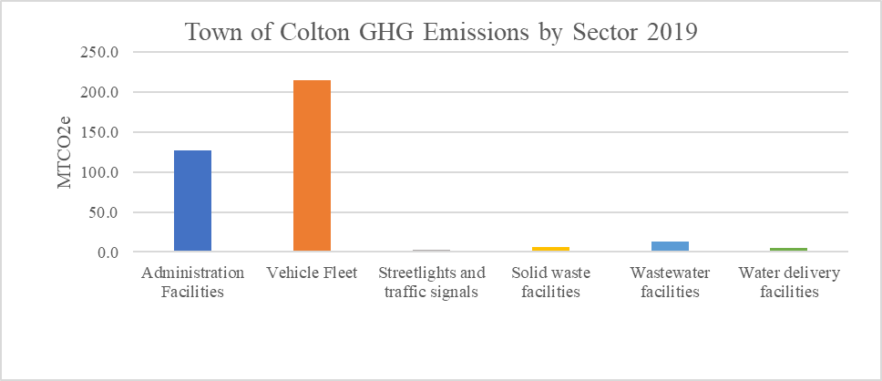
Figure 1: Town of Colton GHG Emissions by Sector for 2019 Bar Chart

Year: 2019 | GHG Emissions (MTCO2e) | Percentage
All Municipal Operations | 368.92 | 100%
Administration Facilities | 126.9 | 34%
Vehicle Fleet | 215.1 | 58%
Streetlights and traffic signals | 2.5 | 1%
Solid waste facilities | 5.7 | 2%
Wastewater facilities | 13.1 | 4%
Water delivery facilities | 5.5 | 1%
Table 1: Town of Colton GHG Emissions by Sector for 2019 in MTCO2e and Percentage

The vehicle fleet and building facilities account for the majority of emissions for the Town of Colton (Figure 1, Table 1). Scope 1 emissions (on-site combustion of fossil fuels) account for a vast majority of the Town of Colton’s emissions for 2019, at 92% (Figure 2). Scope 2 emissions (from electricity) only account for 8% of the Town’s emissions (Figure 2).

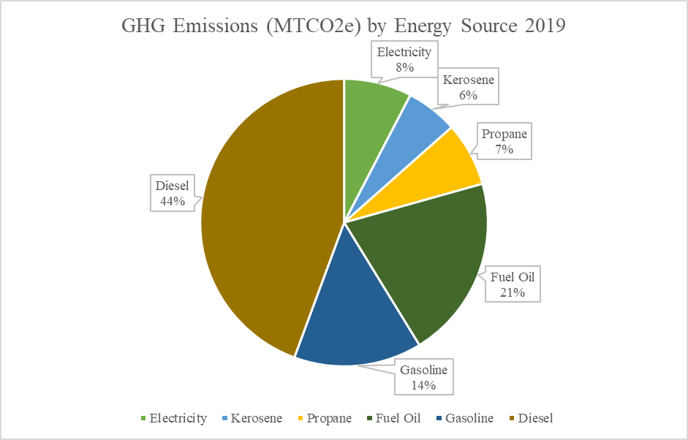
Figure 2: Town of Colton GHG Emissions by Energy Source for 2019

Prioritized Actions to Achieve Emission Reduction Goals

Action | Time Range | Sector/Energy Source
GHG tracking system | Short-term | All
Annually update fleet inventory | Short-term | Vehicle Fleet, Diesel, Gasoline
Zero-emission vehicle rebate | Medium-term | Vehicle Fleet, Diesel, Gasoline
Diesel usage assessment | Short-term | Vehicle Fleet, Diesel
Trash and Recycling Hauling Improvements | Short-term | Vehicle Fleet, Diesel
New Transfer Station Building | Short-term | Administration Facilities, Electricity, Fuel Oil
Electric lawn care equipment | Short-term, Medium-term | Diesel, Gasoline
Building energy audits | Short-term, Medium-term | Administration Facilities, Propane, Kerosene, Fuel Oil
Install heat pumps | Medium-term, long-term | Administration Facilities, Propane, Kerosene, Fuel Oil
Community Distributed Generation | Short-term | Administration Facilities, Electricity
Solar array on closed landfill | Long-term | Electricity
NY Rural Water Assessment implementation | Short-term, Medium-term | Water Delivery, Water Treatment
Table 2: Climate Action Plan Actions Summary

- Implement a greenhouse gas (GHG) tracking system (short- term)
  - The clerk already updates a spreadsheet of energy use (electricity and fuel bills) monthly. A column will be added to the spreadsheet to calculate greenhouse gas (GHG) emissions based on EPA emission factors.
- Annually update Fleet Inventory to prepare for transition to zero-emissions vehicles (short-term)
  - Regularly reviewing the fleet inventory will allow the local government to make informed decisions about fleet purchasing to increase efficiency.
- Apply for DEC’s Zero-Emissions Vehicle (ZEV) rebate program for a zero-emissions vehicle for government operations (medium-term)
- Conduct an in-depth analysis of diesel usage across government operations to find areas for improvement (medium-term)
  - Diesel usage accounts for the majority of GHG emissions for the Town of Colton. Gaining a better understanding of how diesel is used for municipal operations will give the local government a better idea of how to reduce it.
- Purchase electric lawn care equipment (short-term)
  - This will reduce the amount of gasoline and diesel use for municipal operations.
- Energy Audits on municipal buildings (Free CEC Energy Study available through NYSERDA) (short-term)
  - Assessments of building energy use will provide information on which upgrades will provide the most energy savings and the payback periods.
- Install heat pumps to replace fossil fuel heating in municipal buildings (medium-term, long-term)
  - Heat pumps are a highly efficient way to heat and cool buildings as an alternative to on-site fossil fuel combustion.
- Sign municipal electric accounts up for Community Distributed Generation (CDG) (short-term)
  - Community distributed generation (CDG) is an alternative to owning renewable energy (such as rooftop solar). Often, CDG subscriptions provide discounts to municipal accounts that save taxpayer money.
- Look for opportunities to put solar array on closed landfill (long-term)
  - As the Town of Colton begins to transition away from depending on fossil fuel usage, it will be important to ensure an affordable and renewable source of electricity.
- Implement findings from NY Rural Water Association Energy Assessments of Water Delivery and Water Treatment Services (short-term, long-term)
  - Although the water treatment and water delivery services do not account for a high percentage of GHG emissions, there are still opportunities for energy and money savings.

Conclusion
The Town of Colton’s Climate Action Plan has set an ambitious goal to achieve 20 percent reduction of greenhouse gas (GHG) emissions by 2030. Using the greenhouse gas emission inventory as a foundation, this Climate Action Plan has outlined a collection of measures and policies that reduce GHG emissions. With the Climate Action Plan as our guide, the Town of Colton can take effective action in climate change mitigation as we implement municipal and community-wide programs, projects and policies.

