Town of Colton Climate Action Plan for Government Operations

Local Actions for Improving Efficiency, Reducing Greenhouse Gas Emissions, and Saving Taxpayer Dollars

Approved by Town of Colton Town Board
March 20, 2024

Introduction
New York State (NYS) is already experiencing the impacts of climate change and has made climate mitigation one of the top priorities for the state. The Town of Colton is joining other communities in NYS through the Climate Smart Communities (CSC) program to lead the way by launching Climate Action Plans to strategically implement actions that will result in reduced energy demand and GHG emissions in across four focus areas.
The creation of a Climate Action Plan for the Town of Colton will not only address climate protection, but it will also result in energy savings and advance community goals for public health and safety. By choosing to act now, the Town of Colton is taking a leadership role in mitigating the impacts of climate change and aligning its goals with New York State’s Climate Leadership and Community Protection Act (also known as the Climate Act), which requires a reduction in GHG emissions of 40 percent by 2030 and 85 percent by 2050 (below 1990 levels).

The Climate Action Plan identifies GHG emissions resulting from local government operations activities within the Town of Colton. It addresses the major sources of emissions in focus areas and sets objectives and strategies that both the Town of Colton and community can implement to achieve greenhouse gas reductions.

Local Climate Action Planning Process
1. Determine leadership and CAP framework.
2. Develop communication and engagement strategy.
3. Complete and analyze baseline assessments.
4. Identify goals and GHG reduction targets.
5. Identify existing and potential initiatives.
6. Prioritize initiatives.
7. Create a plan for implementing the chosen initiatives.
8. Establish metrics.
9. Write the CAP, adopt it, and make it publicly available.

GHG Reduction Targets
The Climate Action Plan is a critical component of a comprehensive approach to reducing the Town of Colton’s emissions. The Town of Colton is committed to achieving an overall GHG emissions reduction target of 20 percent below the 2019 emission levels by 2030. This reduction target can be met if each focus area implements the list of recommended actions to achieve the reduction target set for that sector. The goals and reduction targets for each of the focus areas are summarized in the following outline.

Town of Colton’s Strategies for Addressing Targets
- Improve efficiency of local government operations and equipment
- Reduce reliance on fossil fuels
- Ensure electricity is coming from renewable, affordable sources
- Implement a household composting program
- Reduce trucking by 30% for transfer station hauling
A prioritized list of actions that address the above targets are included in this document. These specific actions will allow the Town of Colton

Assessing Progress
In order to assess progress, the municipality, in coordination with the Climate Smart Communities (CSC) Task Force, will annually review the Government Operations Climate Action Plan (CAP) and suggest which prioritized actions are appropriate for that year’s budget.
The Government Operations Climate Action Plan will be updated every 5 years. This will allow the Town of Colton to assess progress on this current plan, re-prioritize actions, and adjust to the Town’s changing budget and new funding opportunities.

Financing
It is important for the Town of Colton to make the transition to lower emissions in a financially responsible way. The municipal government will fund the priorities of this Climate Action Plan by pursuing NYSERDA’s Clean Energy Communities program grants, Climate Smart Communities (CSC) grants, and work with regional organizations, such as the Adirondack North Country Association (ANCA), to pursue other grant opportunities.
Previous and Current Climate Initiatives
Climate change is not always separate from the other challenges faced by the Town of Colton, such as budget constraints, water quality, infrastructure maintenance, or community health. Climate change is a result of the land use, transportation and energy use decisions that have evolved over generations and requires coordinated solutions. The Town of Colton has already begun to reduce greenhouse gas (GHG) emissions, both from government operations and the community as a whole, through a variety of plans, programs, policies and actions. With these milestones completed and a Climate Action Plan to guide the way, the Town of Colton is better positioned to implement initiatives to reduce energy use, costs, and GHG emissions for local government operations.
ACTION [YEAR]
- Cobra head streetlights converted to LED [2017]
- Municipal building interior lights converted to LED [2018-2020]
- Infrastructure for biking & walking to reduce vehicle miles traveled in community and to improve safety of residents [Sidewalk extensions in 2017 & 2022, Bike parking at Library 2013, Improved bike & pedestrian signage in 2017 & 2021]
- Organic waste processing at the transfer station (brush collection and food waste collection) [2010]
  - Reduces the amount of weight that needs to be trucked to the landfill
- Reuse program at transfer station [2000]
  - Reduces the amount of weight that needs to be trucked to the landfill
- New transfer station currently being constructed for efficiency and greenhouse gas reductions [Current]
- Fleet Inventory [2024]
  - The fleet inventory will allow the local government to evaluate ways to improve efficiency of the fleet

Local Government GHG Inventory Assessment
A local government operations GHG inventory was conducted for the Town of Colton for the baseline year 2019. The local government GHG emissions inventory accounts for emissions associated with facilities, vehicles, and other processes that are owned and operated by the Town of Colton.

Figure 1 and Table 1 show Town of Colton’s government operations emissions broken down by sector, Figure 2 shows emissions broken down by energy source.

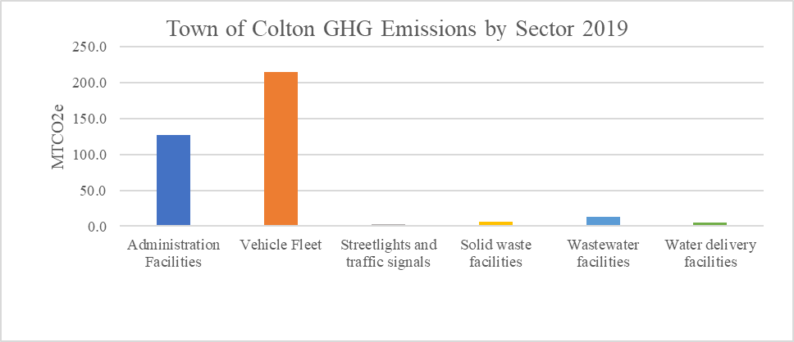
Figure 1: Town of Colton GHG Emissions by Sector for 2019 Bar Chart

Year: 2019 | GHG Emissions (MTCO2e) | Percentage
All Municipal Operations | 368.92 | 100%
Administration Facilities | 126.9 | 34%
Vehicle Fleet | 215.1 | 58%
Streetlights and traffic signals | 2.5 | 1%
Solid waste facilities | 5.7 | 2%
Wastewater facilities | 13.1 | 4%
Water delivery facilities | 5.5 | 1%
Table 1: Town of Colton GHG Emissions by Sector for 2019 in MTCO2e and Percentage

The vehicle fleet and building facilities account for the majority of emissions for the Town of Colton (Figure 1, Table 1). Scope 1 emissions (on-site combustion of fossil fuels) account for a vast majority of the Town of Colton’s emissions for 2019, at 92% (Figure 2). Scope 2 emissions (from electricity) only account for 8% of the Town’s emissions (Figure 2).

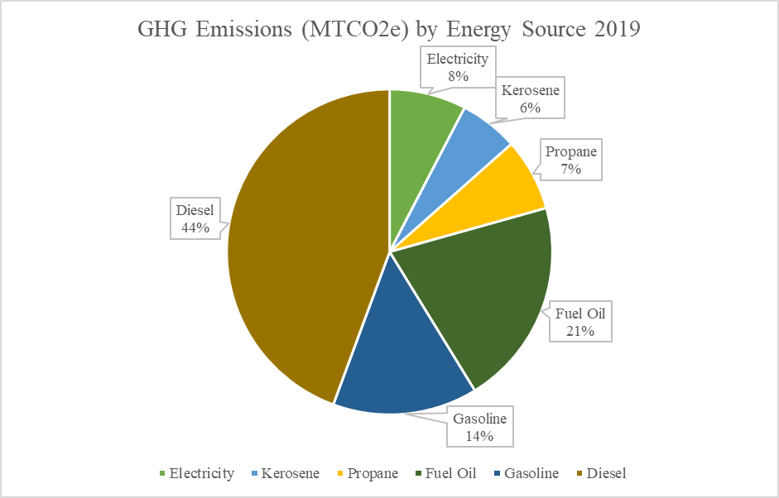
Figure 2: Town of Colton GHG Emissions by Energy Source for 2019

Prioritized Actions to Achieve Emission Reduction Goals

Action | Time Range | Sector/Energy Source
GHG tracking system | Short-term | All
Annually update fleet inventory | Short-term | Vehicle Fleet, Diesel, Gasoline
Zero-emission vehicle rebate | Medium-term | Vehicle Fleet, Diesel, Gasoline
Diesel usage assessment | Short-term | Vehicle Fleet, Diesel
Trash and Recycling Hauling Improvements | Short-term | Vehicle Fleet, Diesel
New Transfer Station Building | Short-term | Administration Facilities, Electricity, Fuel Oil
Electric lawn care equipment | Short-term, Medium-term | Diesel, Gasoline
Building energy audits | Short-term, Medium-term | Administration Facilities, Propane, Kerosene, Fuel Oil
Install heat pumps | Medium-term, long-term | Administration Facilities, Propane, Kerosene, Fuel Oil
Community Distributed Generation | Short-term | Administration Facilities, Electricity
Solar array on closed landfill | Long-term | Electricity
NY Rural Water Assessment implementation | Short-term, Medium-term | Water Delivery, Water Treatment
Table 2: Climate Action Plan Actions Summary

- Implement a greenhouse gas (GHG) tracking system (short- term)
  - The clerk already updates a spreadsheet of energy use (electricity and fuel bills) monthly. A column will be added to the spreadsheet to calculate greenhouse gas (GHG) emissions based on EPA emission factors.
- Annually update Fleet Inventory to prepare for transition to zero-emissions vehicles (short-term)
  - Regularly reviewing the fleet inventory will allow the local government to make informed decisions about fleet purchasing to increase efficiency.
- Apply for DEC’s Zero-Emissions Vehicle (ZEV) rebate program for a zero-emissions vehicle for government operations (medium-term)
- Conduct an in-depth analysis of diesel usage across government operations to find areas for improvement (medium-term)
  - Diesel usage accounts for the majority of GHG emissions for the Town of Colton. Gaining a better understanding of how diesel is used for municipal operations will give the local government a better idea of how to reduce it.
- Purchase electric lawn care equipment (short-term)
  - This will reduce the amount of gasoline and diesel use for municipal operations.
- Energy Audits on municipal buildings (Free CEC Energy Study available through NYSERDA) (short-term)
  - Assessments of building energy use will provide information on which upgrades will provide the most energy savings and the payback periods.
- Install heat pumps to replace fossil fuel heating in municipal buildings (medium-term, long-term)
  - Heat pumps are a highly efficient way to heat and cool buildings as an alternative to on-site fossil fuel combustion.
- Sign municipal electric accounts up for Community Distributed Generation (CDG) (short-term)
  - Community distributed generation (CDG) is an alternative to owning renewable energy (such as rooftop solar). Often, CDG subscriptions provide discounts to municipal accounts that save taxpayer money.
- Look for opportunities to put solar array on closed landfill (long-term)
  - As the Town of Colton begins to transition away from depending on fossil fuel usage, it will be important to ensure an affordable and renewable source of electricity.
- Implement findings from NY Rural Water Association Energy Assessments of Water Delivery and Water Treatment Services (short-term, long-term)
  - Although the water treatment and water delivery services do not account for a high percentage of GHG emissions, there are still opportunities for energy and money savings.

Conclusion
The Town of Colton’s Climate Action Plan has set an ambitious goal to achieve 20 percent reduction of greenhouse gas (GHG) emissions by 2030. Using the greenhouse gas emission inventory as a foundation, this Climate Action Plan has outlined a collection of measures and policies that reduce GHG emissions. With the Climate Action Plan as our guide, the Town of Colton can take effective action in climate change mitigation as we implement municipal and community-wide programs, projects and policies.

